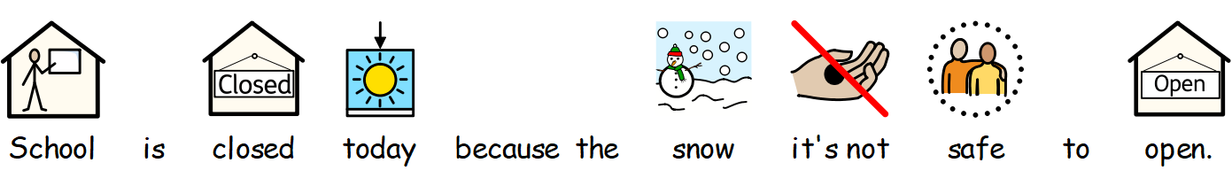
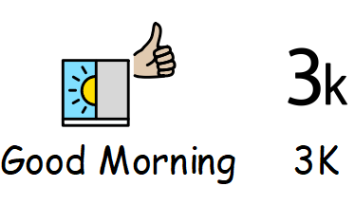

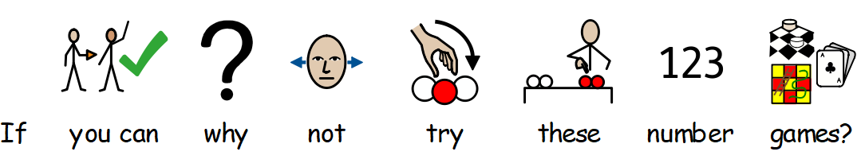

https://uk.ixl.com/maths/reception/which-table-is-correct
https://uk.ixl.com/maths/reception/interpret-data-in-tables
https://uk.ixl.com/maths/reception/tally-marks-up-to-10
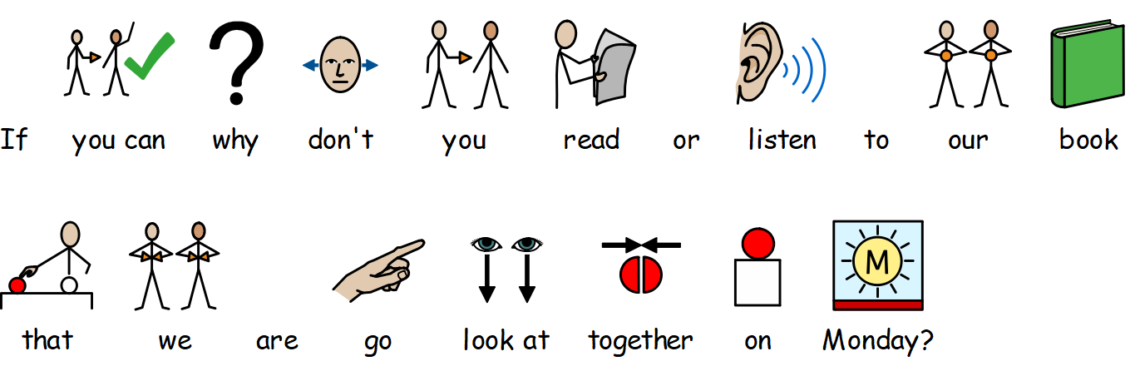
https://uk.ixl.com/maths/year-1/which-tally-chart-is-correct

This Is How a Tadpole Transforms Into A Frog | The Dodo - YouTube
🐸🐠 TAD Read Aloud | Book by Benji Davies - YouTube
Tad by Benji Davies - YouTube
FROGS | Educational Videos for Kids - YouTube
The Sentence Song | English Songs | Scratch Garden - YouTube
