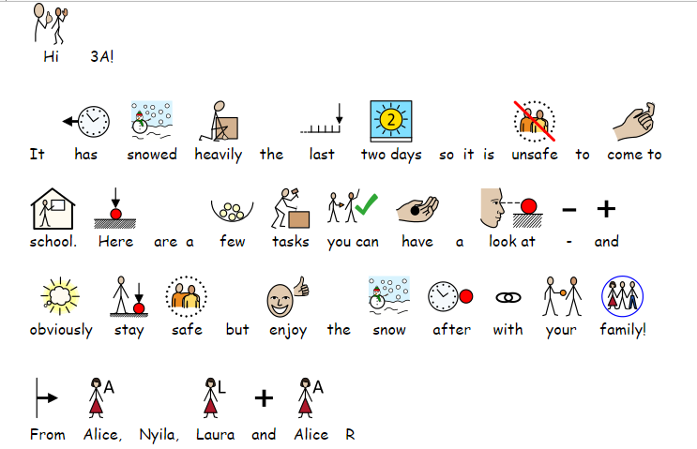

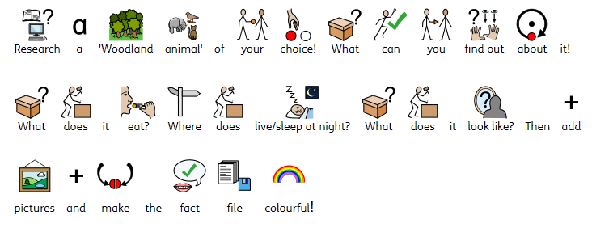

My Animal Fact File: ___________________________

____________________________________________________________________________________________________________________________________________________________________________________

____________________________________________________________________________________________________________________________________________________________________________________

____________________________________________________________________________________________________________________________________________________________________________________

My Animal Fact File: ___________________________

____________________________________________________________________________________________________________________________________________________________________________________

____________________________________________________________________________________________________________________________________________________________________________________

____________________________________________________________________________________________________________________________________________________________________________________



